
Apprentice Painter and Decorator: Two fixed term contract (FTC) posts for 3 years, subject to review
Candidate Information Pack - June 2026


Welcome from Belfast City Council Chief Executive, John Walsh
 | “Thank you for your interest in Belfast City Council’s Apprenticeship Programme.  As an apprentice, you will have the opportunity to gain a recognised qualification and work with experienced staff, develop your skills and help Belfast City council deliver a range of services that touch the lives of everyone in this city.”

About Apprenticeships at Belfast City Council

Apprenticeships are a great way to study, gain experience and earn money while you do.  As an apprentice at Belfast City Council, you will be supported to gain an accredited qualification, develop skills and the experience to access a wide range of career opportunities. You will work with colleagues to deliver better services for the people of Belfast. | 

Who we are?
Belfast City Council is the largest local authority with responsibility for the city of Belfast, the capital and largest city in Northern Ireland. The Council's geographical footprint is only 132km², however it serves an estimated population of 348,005, the largest district council in Northern Ireland.
The Council is made up of 60 elected representatives. We deliver high quality, effective and efficient services to improve the lives of the people of Belfast.

Our Vision and Values
Our Vision

Our community plan “The Belfast Agenda” sets out our city priorities for 2035, where Belfast will be a city re-imagined and resurgent. A great place to live and work for everyone.

Our Values

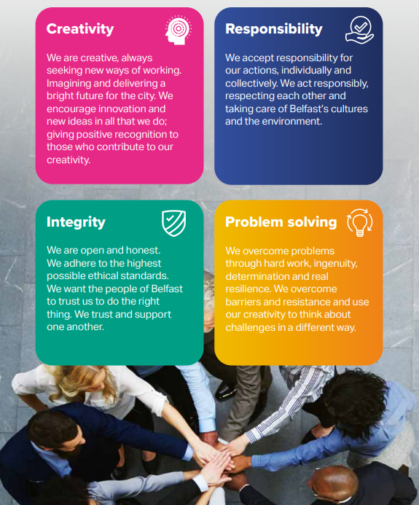

Our Corporate Management Team

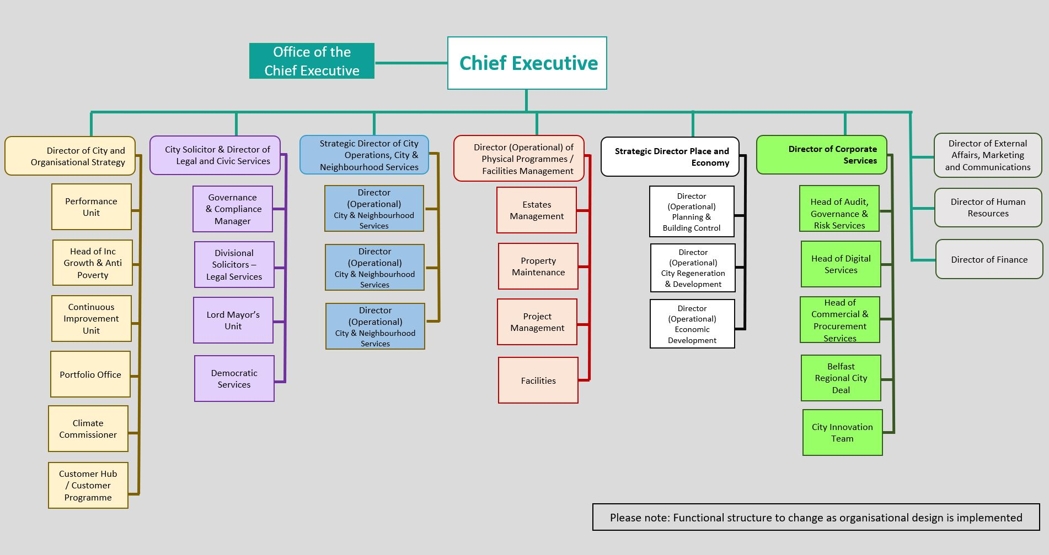

Selection Process

Candidates must submit an application form to apply for these 3-year Fixed Term Contract Apprentice Painter and Decorator posts. The online application form can be accessed via our recruitment system. Please refer to the Job Description and Employee Specification (next page) for the post when completing the application form. Please also refer to the Terms and Conditions of Employment (available online) for full details of these posts.
Recruitment Timeline
Stage | Date
Apprentice Painter and Decorator Information / Familiarisation Session | Thursday 18 June 2026
Closing date for applications | Monday 29 June 2026
Tests to be completed in person | Thursday 16 July 2026; Friday 17 July 2026; or Monday 20 July 2026
Interviews to be completed in-person | Wednesday 19 August 2026; Thursday 20 August 2026; or Friday 21 August 2026

Job Description
Ref No: |  | Date: | March 2026

Dept: | Property and Projects
Section: | Property Maintenance
Job Title: | Apprentice Painter and Decorator
Grade: | Grade 1

Main purpose of job
To be responsible to the Working Trades & Services Supervisor (Fabric) or another appropriate officer.

To work alongside qualified craft personnel, to observe and absorb the various processes and practices associated with the relevant trade, and to apply this knowledge to undertake relevant painting and decorating work within the Property Maintenance Operation, either individually or as part of a team.

Summary of responsibilities and personal duties
- Carry out the full range of duties associated with his or her trade apprenticeship to ensure the delivery of a high quality, responsive and customer focused service.

- Assist in carrying out a range of painting and decorating duties including, but not limited to:
  - Maintaining, storing and using all types of painter’s tools, e.g., ladders, trestles, staging, brushes, knives and trays etc.
  - Preparing surfaces for painting and decorating including the removal of existing paints, finishes, and wallpaper, washing walls, and minor repairs to surfaces.
  - Preparing the surrounding area including the protection and covering of fixtures and furniture and masking of surfaces and features.
  - Mixing and matching paints and textures as required.
  - The application of paints, varnishes, stains, glazes, and other finishes, including undercoats, gloss, emulsions, paste, hanging wallpapers and other decorative products e.g. ‘Muraspec’ in accordance with installation instructions and manufacturers data sheets.
  - Ensuring the proper and safe use and storage of solvents, thinners, and diluents.
  - Treating in the correct manner, cracking, flaking, blistering etc of surfaces.

- Assist in the delivery of a planned and reactive maintenance programme including the use of all ICT hardware and software supplied, appropriate to the role.

- Work across all Belfast City Council properties and to assist craftspeople as directed in both internal and external locations.

- Assist in the interpretation of working drawings, specifications, and painting schedules as required.

- Assist in the identification, ordering and collection of materials as required.

- Provide as required, all job-costing and time-recording information.

- Attend as specified any/all academic training forming an agreed part of the
apprenticeship programme and to submit and maintain any associated paperwork.

- Successfully complete all aspects of the apprenticeship including but not limited to exams, skill tests, coursework, course attendance, and on-the-job training.

- Attend any/all review or other meetings scheduled as part of the apprenticeship programme.

- Drive Council vehicles as required.

- Assist in the safe erection and dismantling of scaffolding as required which involves working at heights and the utilisation of mobile elevation equipment.

- Ensure all work carried out is carried out in accordance with Health & Safety at Work Legislation, CDM Legislation and Council regulations.

- Undertake any other duties as required by the Working Trades & Services Supervisor (Fabric) and any other appropriate officer or manager, within the post-holder’s sphere of responsibility.

- Participate in all induction and in-service training provided by Belfast City Council and in the induction and support of all newly appointed staff and other human resource management policies and procedures, as appropriate, including, absence management, disciplinary and grievance procedure.

- Act in accordance with the council and departmental policies and procedures including customer care, equal opportunities, health and safety, safeguarding and any pertinent legislation.

- Undertake the duties in such a way as to enhance and protect the reputation and public profile of the council.

- Undertake such other relevant duties as may from time to time be required.

This job description has been written at a time of significant organisational change, and it will be subject to review and amendment as the demands of the role and the organisation evolve. Therefore, the post-holder will be required to be flexible, adaptable and aware that they may be asked to perform tasks, duties and responsibilities which are not specifically detailed in the job description, but which are commensurate with the role.
E
Employee Specification
Date: | 26 May 2026

Department: | Property and Projects
Section: | Property Maintenance
Job title: | Painter and Decorator
Grade: | Grade 1

Qualifications

None required but the post-holder will be required to attain the following target qualifications:

- City & Guilds Level 2 Diploma in Painting and Decorating;
- City & Guilds Level 2 NVQ in Decorative Finishing and Industrial Painting Occupations (Construction); and
- City and Guilds Level 3 NVQ in Decorative Finishing – Painting and Decorating (Construction).
Experience

None required. Belfast City Council will provide the post-holder with full training, practical skills and site knowledge.

Essential criteria

In order to be shortlisted for the post, applicants must be able to demonstrate that they have, or they understand, or they have some awareness of the importance of each of the following 7 special skills and attributes in the relevant section of the application form.

Special skills and attributes

1. Communication skills: Good oral communication and listening skills in dealing with colleagues, line managers, clients, project managers and contractors.

2. Team working and the ability to work on own initiative: the ability to work productively both as part of a team and on the basis of personal initiative.

3. Customer care skills: the ability to respond appropriately to all customers including members of the public, council officers and elected representatives in a helpful and positive manner, creating a good impression and enhancing the reputation of the council and its workforce.

4. Health and safety: a basic understanding of the health and safety responsibilities attached to the post to ensure your safety, the safety of other council employees, and members of the public.

5. Work planning and organisational skills: the ability to plan and prepare for your assigned tasks.

6. Technical knowledge: a basic understanding of painting and decorating tasks.

7. Information technology skills: the ability to use basic IT applications, as and when required.

These special skills and attributes may also be further assessed at interview.

Applicants who can demonstrate that they have, or they understand, or they have some awareness of the importance of the above special skills and attributes in their application form will be shortlisted to undertake a number of computer-based aptitude tests for the post.

These online aptitude tests must be undertaken “in-person” by applicants in the Council’s Computer Suite, First Floor, 9 Adelaide Building, Belfast and applicants must provide photographic ID on the day they undertake these online tests.

The online aptitude tests will assess applicants’ Basic Numeracy, Reading Measurements, Understanding Instructions and Health and Safety awareness.

Applicants must pass these online aptitude tests to a satisfactory level and within a satisfactory timeframe in order to be invited to the final stage of the selection process, which is an “in-person” interview on council premises.

NB: The scores attained in the online aptitude tests may be carried forward to the interview scores.

Benefits of working at Belfast City Council
We expect a lot from you, and we offer a lot in return for your passion and commitment. We offer a wide range of benefits including a pension, generous annual leave entitlements and health and wellbeing initiatives.
We are committed to supporting our communities and our employees. With benefits including competitive salaries, excellent learning and development and career opportunities, as well as a focus on work-life balance, there are many reasons to join our team.
We believe that every Belfast City Council employee plays an important role in making life better for our residents. So, if you want to build a career with us, have a look at some of the benefits on offer:
We are an accredited Real Living Wage employer, offering a competitive and progressive salary scale.
The salary scale for the Apprentice Painter and Decorator role is Grade 1, SCP 2-5 currently £24,413 - £25,583.

And looking to the future, we offer an attractive pension scheme. As your employer, we contribute around 19% to your pension. As an employee, you pay between 5.5% and 10.5%, depending on your salary.
The hours of duty are 37 per week, working pattern as follows –

During term time: 8.00am – 4.30pm Monday to Thursday, and 8.45am – 2.15pm on Friday (Friday is classroom based with the training provider)

During non-term time: 8.00am – 4.30pm Monday to Thursday, and 8.30am- 1.00pm on Friday. The person appointed may also be required for operational reasons to work outside these hours including on extra statutory, bank and/or public holidays.

Annual leave entitlement

We offer a generous annual leave entitlement, starting at 24 days and rising to 32 days, based on length of service.
Employees also benefit from an additional 12 extra statutory, bank or public holidays each year.

Additional leave provisions
We have a number of enhanced leave provisions in place. These include maternity, paternity, adoption, special leave and bereavement leave.
Health & Wellbeing
We invest in your health & wellbeing through policies, procedures and strategies. We promote a range of initiatives and activities such as discounted leisure centre membership and a cycle to work scheme.
Equality & Diversity
We celebrate diversity in our workforce and energise this with our three staff networks:

- ABLE – Disability Support Network

- Proud – LGBTQIA+ Staff Network

- The Women’s Network

These networks provide opportunities to engage and work with staff across the organisation and external stakeholders to support equality and diversity.

These qualifications will be funded by Belfast City Council. The post-holder will be required to successfully attain Qualifications 1 and 2 in Year 1 in order to be eligible to commence studies in Year 2 to attain Qualification 3.

